Year | Teaching | Professional Service | Scholarship | Tenured | Promoted
2006-2007 | Good | Good | Unacceptable | 0 | 1
2007-2008 | Good | Good | Unacceptable | 0 | 0
2008-2009 | Good | Good | Unacceptable | 0 | 0

 | Faculty 1 | Faculty 2 | Faculty 3 | Faculty 4 | Faculty 5 | Faculty 6 | Faculty 7
Teaching | Good | Excellent | Good | Good | Good | Good | Good
Professional Service | Excellent | Good | Good | Excellent | Excellent | Excellent | Good
Scholarship | Unsatisfactory | Acceptable | Acceptable | Good | Unsatisfactory | Good | Unsatisfactory
Tenured |  |  |  |  |  | 
Promoted

The most recent survey/evaluation results…
Teaching Summary
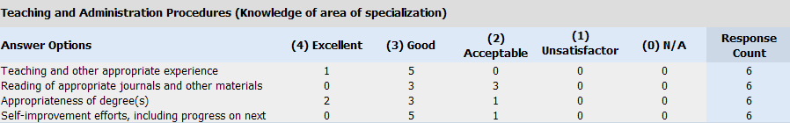
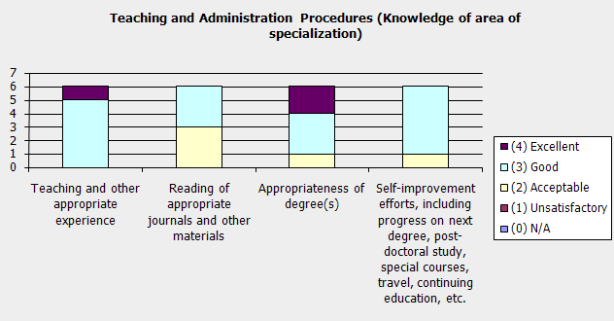

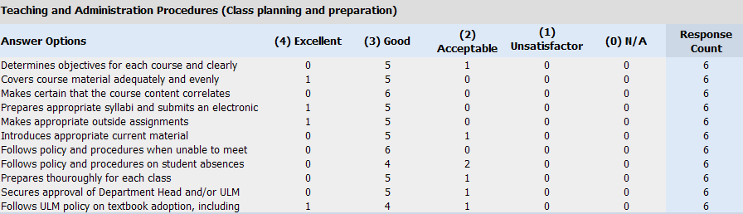
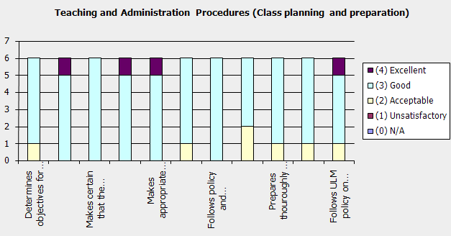

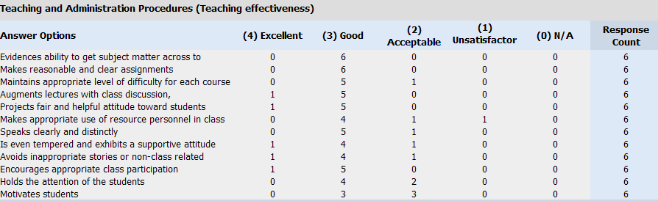
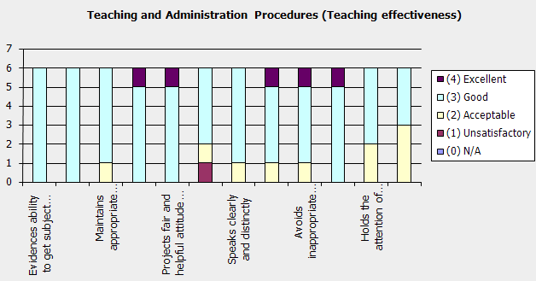

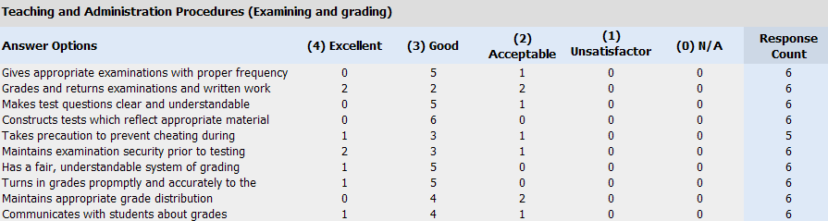

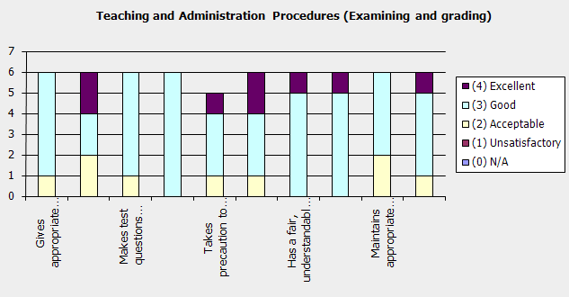

Service Summary

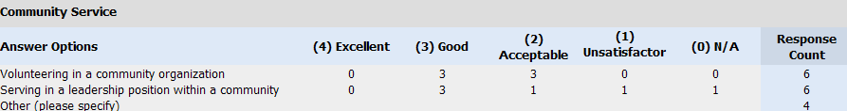
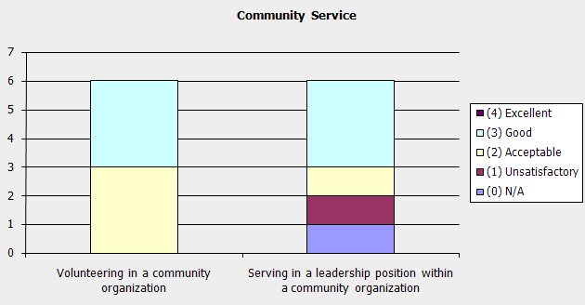

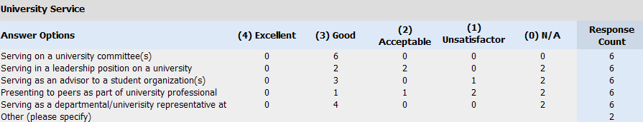

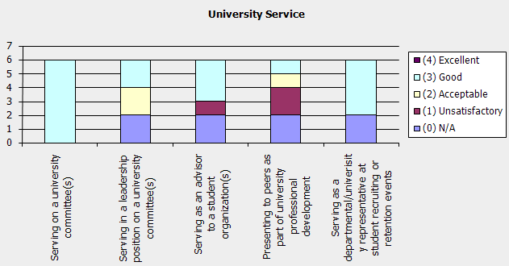

Research/Scholary Activity Summary

